DEDICATION

THIS WORK IS DEDICATED
TO MY LOVELY FAMILY

ACKNOWLEDGEMENTS
The accomplishment of this great project won’t have been a success without out the important contributions of a good number of people who gave me a huge support academically, professionally, financially and even spiritually. I then direct my appreciations to:
- Mr. Armand Claude ABANDA, the Resident Representative of AICS Cameroon for creating the Anglophone section offering the software engineering field and also for his encouragements and follow-ups. Also, for permitting us carry our internship at his institute AICS Cameroon.
- My professional Supervisor Mr.TCHOUA NANA SAMORY for his time, advices, and follow-up throughout these periods.
- My academic Supervisor Mr. KAPNANG RUFUS for his time, advices, and follow-up throughout these periods
- To my teachers for their words of encouragement, trust and time invested during this period.
- To my lovely family DOFOR, my mum and dad must especially, thanking them for their continuous prayers, blessings, support (spiritual and financial support) and encouragements. A special thanks to my uncles and aunts.
- Mr. AGBOR ANDERSON for his time, advices, and follow-up throughout these periods.
- Mr. MESSIO for his time, advices, and follow-up throughout these periods.

SUMMARY
DEDICATION 1
ACKNOWLEDGEMENTS 2
SUMMARY 3
LIST OF FIGURES 4
LIST OF TABLES 6
LIST OF ABBREVIATIONS 7
ABSTRACT 8
RESUME 9
GENERAL INTRODUCTION 10
PART I : INSERTION PHASE 11
PART 2: TECHNICAL PART 24
CHAPTER I: EXISTING SYSTEM 25
CHAPTER VI: REALIZATION PHASE 96

LIST OF FIGURES
Figure 1 Localisation of interlink 17
Figure 2 table of partners 18
Figure 3 Organistional chart of interlink 20
Figure 4 software resources of interlink 22
Figure 5limitation of the existing system and proposed solution 33
Figure 6software resources 44
Figure 7hardware resources 45
Figure 8human resources 45
Figure 9hardware resources needed 46
Figure 10projects planning 46
Figure 11table of participants 49
Figure12UML HEIRACHY 55
Figure13comparative study between uml and merise 56
Figure 142-TUP 57
Figure 15USECASE formalism 60
Figure16components of the use case diagram 61
Figure 17graphical representation of the usecase diagram 62
Figure 18manage user specific usecase 63
Figure 19manage account specific usecase(passenger) 64
Figure 20communication diagram of authentication 70
Figure 21communication diagram block user 71
Figure 22communication diagram block user 72
Figure 23sequence diagram formalisme 73
Figure 24sequence authentication 75
Figure 25sequence block user 76
Figure 26sequence delete contact 77
Figure 27activity diagram authentication 80
Figure 28activity diagram of scan QR code 82
Figure 29activity of block user 83
Figure 30activity diagram of delete contact 84
Figure 31system physical architecture 89
Figure 32MVC illustration 90
Figure 33class diagram formalism 91
Figure 34state machine formalism 94
Figure 35 create account 96
Figure 36pachege diagram formlism 97
Figure 37pachage diagram 99
Figure 38component of the deployment diagram formalism 104
Figure 39deployment diagram 106
Figure 40components diagram formalism 107
Figure 41component diagram 109

LIST OF TABLE

Table 1textual description of some usecase 65
Table 2generate time table textual description 66
Table 3comunication diagram formalism 68
Table 4component of the communication diagram 69
Table 5component of the sequence diagram 74
Table 6formalism of the activity diagram 78
Table 7components of an activity diagram 79
Table 8component of class diagram 92
Table 9graphical representation of the class diagram 93
Table 10component of the state machine diagram 95
Table 11component of the package diagram 98
Table 12component of the deployment diagram 105
Table 13component of the component diagram 108
Table 14hardware material use for the developmentt 110

LIST OF ABBREVIATIONS
2TUP: Two Track Unified Process

API: Application programming Interface AICS: African institute of Computer Science CD-ROM: Compact Disk- Read Only Memory CRUD: Create Read Update Delete;
DBMS: Database Management System

ICT: Information and Communication Technology

MVC:Model view contrll
SDLC: System Development Life Cycle

ABSTRACT
Humanity has stopped evolving. In fact, it has evolved at an exponential rate over the pass few centuries, driven by innovations in technology. From the agricultural revolution to the industrial revolution then to information and communication technology revolution, we have developed new tools that has allowed us transform our world in ways that were unimaginable. Thus, we cannot see the future without technology. These new technological advances have had a profound impact on our lives changing the way we work, the way we communicate and the way we interact with the world around us. For this reason, the African Institute of computer sciences is committed to making Cameroon a key player in the information and communication technology revolution. To archive this, AICS offers its students practical trainings through academic internship. This internship gives students the opportunity to apply their theoretical knowledge to real world problems. In line with these perspectives, we approach INTERLINK, which is an enterprise that host our internship. During our induction phase, we were assigned the theme” Conception and Implementation of a “SMART URBAN TAXI SECURITY AND INCIDENTS DETECTION SYSTEM”. Following our theme, we conducted feasibility studies, followed by analysis, then via conception and realization phases. The application was developed using Nodejs, Vue.js and in order to obtain a flexible and secure solution.
Keywords:
  - ARTIFICIAL ITELIGENCE
  - SCHEDULING
  - COMMUNICATION

RESUME
L'humanité n'a pas cessé d'évoluer, bien au contraire, elle a évolué à un rythme exponentiel au cours des derniers siècles, stimulée par les innovations technologiques. De la révolution agricole à la révolution industrielle, puis à la révolution des technologies de l'information et de la communication, nous avons développé de nouveaux outils qui nous ont permis de transformer notre monde de manière inimaginable. Ainsi, nous ne pouvons pas concevoir l'avenir sans technologie. Ces avancées technologiques ont eu un impact profond sur nos vies, changeant la façon dont nous travaillons, communiquons et interagissons avec le monde qui nous entoure. Pour cette raison, l'Institut Africain d'Informatique (IAI) s'est engagé à faire du Cameroun un acteur clé de la révolution des technologies de l'information et de la communication. Pour atteindre cet objectif, l'IAI offre à ses étudiants des formations pratiques à travers des stages académiques. Ce stage donne aux étudiants l'opportunité d'appliquer leurs connaissances théoriques à des problèmes du monde réel. Dans cette optique, nous nous sommes adressés à INTER-LINK, une entreprise qui accueille notre stage. Lors de notre phase d'induction, nous avons été assignés au thème " Conception et Mise en Œuvre Système intelligent de sécurité et de détection d'incidents pour taxis urbains". Suivant notre thème, nous avons effectué des études de faisabilité, suivies d'une analyse, puis des phases de conception et de réalisation. L'application a été développée en utilisant Nodejs, Vue.js afin d'obtenir une solution flexible et sécurisée.
Mots-clés :
- Intelligence artificielle
- Internet des Object
- Planification
- communication

GENERAL INTRODUCTION
In today's urban transportation lands cape, taxi and ride-hailing operators face growing challenges in ensuring passenger and driver safety while managing daily operations efficiently. Traditional fleet management system focus mainly on administrative tasks such as trip scheduling, driver assignment, and record keeping, often neglecting real-time safety monitoring and proactive incident detection. This gap limits timely intervention during emergencies and hinders the ability of operators to protect both drivers and passengers throughout a trip. To overcome these limitations, this project presents the conception and implementation of an intelligent urban taxi security system that leverages artificial intelligence to detect incidents in real time and provide automated safety responses. The system seeks to combine operational efficiency with AI-driven decision support, offering real-time monitoring, anomaly detection, and data-based alerts to enhance passenger security and driver protection. The project's analysis and design adopt the 2TUP (Two-Track Unified Process) methodology, emphasizing both business and system modeling for a comprehensive understanding of user needs and system functionalities. Using UML (Unified Modeling Language) diagrams such as use case, class, sequence, and activity diagrams the system is modeled to represent its behavior, user interactions, and data structures. This structured analytical approach establishes a solid foundation for subsequent design and implementation phases.
Project Phases:
- Insertion Phase: Defines project context, objectives, and overall purpose.
- Existing System: Manual, slow, decentralized, and prone to information gaps.
- Specification Book: Lists system requirements and development guidelines.
- Analysis Phase: Identifies user needs and system functionalities.
- Conception Phase: Designs system architecture and component interactions.
- Realization Phase: Develops and integrates the designed system modules.
- Functionality Testing Phase: Verifies system performance and requirement compliance.
The user guide: Explains registration, navigation, and application process clearly

PART I : INSERTION PHASE

Preamble

The insertion phase document presents the internship environment, the structure of the organization, the conditions in which the interns were received, as well as the project to be realized during the internship.

Content :
INTRODUCTION
- WELCOME AND INTERGRATION
- GENERAL PRESENTATION OF INTERLINK
- HARDWARE AND SOFTWARE RESOURCES OF WELLD OF INTERLINK
- ORGANIZATION OF INTERLINK
- BRIEF PRESENTATION OF PROJECT
CONCLUSION

INTRODUCTION

Social and professional integration refers to the process by which an individual is integrated into the social and economic context by adopting the norms and rules that govern it. In the following sections, we will begin by describing our reception and integration within the company INTERLINK. Then, we will explain its overall structure as well as its organizational chart

WELCOMING AND INTERGRATION

Welcome
Upon our arrival at INTERLINK, the reception was very simple. We were first taken to the meeting room, introduced to each team member, and then each of us introduced ourselves with our name, class, school, reason for being there, duration of the internship, and how we were admitted.
The Director then gave a welcome speech and instructed the intern coordinator to give us a full tour of the company. Finally, based on our academic fields, we were assigned to different departments

Integration
At first, adjusting was quite intense due to the workload and pressure of meeting tight deadlines. However, after three days, adaptation was achieved.

GENERAL PRESENTATION OF INTER-LINK

History
INTERLINK is a company specializing in software development, online presence management, digital marketing, tech consulting, systems maintenance, IT training and consultancy, network design and implementation, and surveillance camera installation.
It was founded in 2025 by Mr. TCHOUA NGATCHOU NANA Samory and Mr. BANGOUP Rufin, who had a futuristic vision for digital transformation in businesses. Today, INTERLINK supports and works with over 10 companies aiming to align with digital standards. Its headquarters is in Yaounde, with a branch office in Douala.

Geographical location
INTERLINK is located at Abang, 3 kilo meters from AWAE Escalier.

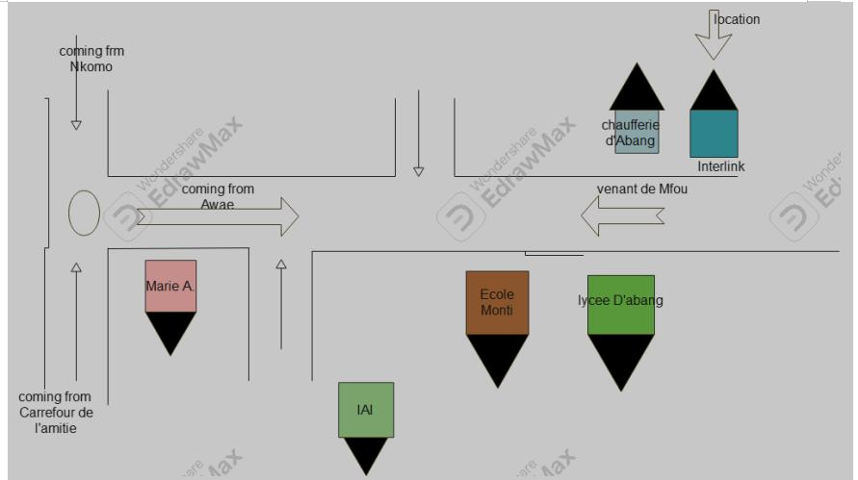
Figure 1 Localisation of interlink

Mission
INTERLINK main mission is to promote digital transformation for individuals and businesses. Its objectives include:
- Providing a new image of Africa (especially Cameroon) to the world by helping businesses move from analog to digital to improve performance.
- Creating software, logos, flyers, websites, and network installations.
- Offering quality training to company staff and individuals, believing every African should master digital tools.

Activities, Achievements and Partners.

ACTIVITIES
INTERLINKis a key player in digital transformation across various businesssectors. Its solutions include:
- System Integration: Helping companies adapt to digital tools.
- IT Strategy and Organization Consulting: Advising on IT service organization and strategies.
- Project Management: Supporting businesses throughout project execution.
- Communication & Digital Marketing: Handling online presence, including web design and content.
- Development Web & Mobile Application: Building websites and apps with attention to quality.

ACHIEVEMENTS
- Design and implementation of a Travel Management System (TMS) for GHF SARL
- Network deployment and maintenance for SOCADEP, CWORTH ENERGY, and individuals
- Installation of surveillance systems at EMERIX COMPANY and private residences
- Design of logos and flyers for INTERLINK, LA PETITE BAYAM,
FONDATION PAVI, and individuals
- Online presence management for LA PETITE BAYAM, INTERLINK,
PENTIUM GSM, and others
- Creation of a professional training center with JPTEKS
- Maintenance of IT equipment for FONDATION PAVI and others.

PARTNERS
INTERLINKas an economic enterprise has the following partners who greatly help in the development of their enterprise.

Figure 2 table of partners
PARTNERS | LOGO
SOCADEP
EMERIX.
JPTEKS
PENTUIM GSM | 

□ FONDATION PAVI.

ORGANIZATIONAL CHART OF INTERLINK

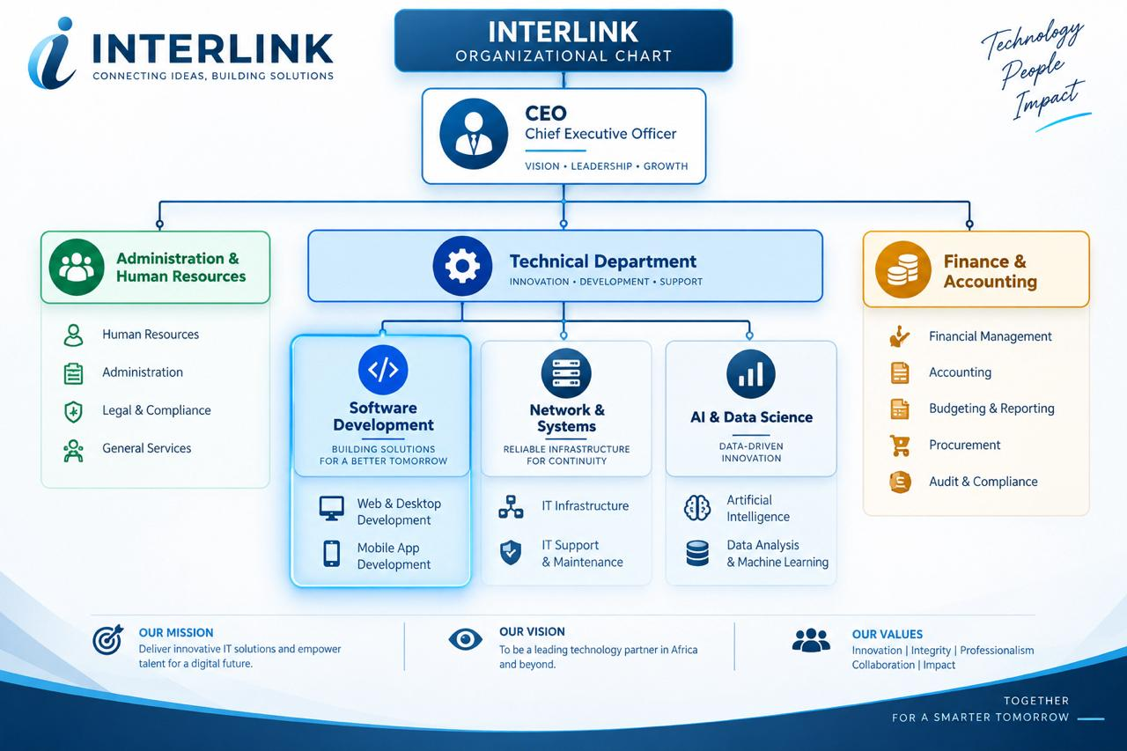
INTERLINK has several departments. We were assigned to the Technology Department
Figure 3 Organistional chart of interlink

ORGANIZATIONAL CHART OF INTERLINK
INTERLINK has several departments. We were assigned to the Technology Department.

IV. COMPANY RESOURCES

1. Hardware Ressource
Tableau 2 hardware ressource of smart-tech
N | Equipment | Characteristic | Quantity
1. | Computer sever |   Desktop HP | 03
2. | Laptop computer |   Laptop HP | 05
2. | Laptop computer |   Laptop Dell | 05
3. | Routers |   Cisco catalyst 1941 | 01  01
3. | Routers |   Tp-link (wifi) | 01  01
4. | Switch |   Switch cisco catalyst 24 ports | 01
5. | Optic fibre | Camtel | 01
6. | Modem | Modems MTN 4G 01  Modems Toplink 5G | 01  01
7. | Ethernet cable | Twisted pair CAT6 | 01

3.Software Resources
Figure 4 software resources of interlink
N° | Software | Description
01 |   Office suite | Standard Office Suite for creating documents, spreadsheets, presentations, and other professional content.
02 |   Windows 11 | Operating System for computer.
03 |   WPS | Word Processing software.
04 |   Adobe suit | Professional Suite for image editing, illustration creation, video editing, and audio editing.
05 |   Canva | Online Graphic Design Platform for creating professional visuals, presentations, social media publications, etc.
06 |   Visual studio code | IDE (Integrated Development Environment), a free and open-source environment, very popular for web and mobile development.
07 |   Wamp | Local Web Development Environments, including Apache, MySQL, and PHP, for testing and deploying web applications locally before putting them online.
08 |   Cisco ISE | Authentication Management Tools (such as Active Directory) for managing authentications within information systems
09 |   ENSP of HUAWEI | Email Monitoring Software (such as Microsoft Exchange Monitor), a useful tool for monitoring and optimizing mail server operations
10 |   SolarWinds | Email Monitoring Software (such as Microsoft Exchange Monitor), a useful tool for monitoring and optimizing mail server operations
11 |   EVE NG | GNS3 (or other network simulation software), a software for simulating networks through clientless virtualization.
12 |   Eclipse | Open-source Integrated Development Environment (IDE)Used for software development in various languages, including:Java, C++, Python, PHP
 |   GitHub | Source Code Management Platform, used to store, share, and collaborate on software projects.

CONCLUSION
Upon completing our integration, we have gained a thorough understanding of the work environment in which we will be operating during our internship. We have acquainted ourselves with the structure's history, missions, responsibilities, organization, various resources, and organizational chart, enabling us to confidently proceed to the second part of the report, the specifications document.

PART 2: TECHNICAL PHASE

CHAPTER I: EXISTING SYSTEM

Preamble:

The insertion phase helped us to establish a comprehensive understanding of the host organization. This phase emphasizes on the key characteristics, specificities, and objectives of the designated study subject

Content :
INTRODUCTION
- PRESENTATION OF THEME
- DESCRIPTION OF THE EXISTING SYSTEM
- CRITICISM OF THE EXISTING SYSTEM
- LIMITATIONS OF EXISTING SYSTEM
- PROBLEMATIC
- PROPOSED SOLLUTION
CONCLUSION

INTRODUCTION

Engineers are society's problem-solvers, working to make life easier for everyone. Before proposing solutions, we need to understand the root causes of the problem and how it's currently addressed. Analysing existing systems in our field is key to identifying problems and developing effective solutions. This ensures our proposals improve upon or replace the current system for the better

PRESENTATION OF THEME
Urban transportation operators, though committed to providing safe and reliable mobility services, face increasing challenges in effectively protecting drivers and passengers during trips and responding quickly to emergencies. Traditional taxi and ride-hailing management systems make it difficult to detect incidents as they happen, verify the identity of drivers and vehicles, and provide timely intervention when a passenger or driver is in danger.
To address this, implementing a smart urban taxi security and incident detection system powered by artificial intelligence (AI) is essential. This system will not only streamline fleet and trip management but also enhance passenger and driver safety by providing real-time incident detection, automated alerts, and rapid emergency response. It will facilitate continuous monitoring of trips, identify abnormal or dangerous situations, and connect affected users directly with monitoring centers and emergency services.
By leveraging modern technology such as onboard sensors, computer vision, and real-time data analysis, taxi operators can improve the safety of urban transportation, increase passenger confidence, and provide a secure environment that protects both drivers and passengers. This innovative solution is designed to contribute to safer cities by combining efficient trip management with AI-driven security support.
THEME:
CONCEPTION AND IMPLEMENTATION OF A SMART URBAN TAXI SECURITY AND INCIDENT DETECTION SYSTEM

DEFINITION OF TERMS
- Artificial Intelligence (AI): The capability of a machine or system to simulate human intelligence by analyzing data, recognizing patterns, and making recommendations or predictions.
- Taxi Security System: A software and hardware platform designed to monitor, protect, and manage the safety of drivers and passengers during taxi trips.
- Incident Detection: The systematic, real-time analysis of sensor data (video, audio, motion) to identify events such as assaults, accidents, or hijacking attempts.
- Emergency Response: A coordinated process of alerting monitoring centers and emergency services, and dispatching help, following a detected or reported incident.

DESCRIPTION OF THE EXISTING SYSTEM
The current system for managing taxi operations, trip safety, and incident response in most urban settings is still manual and fragmented, creating several inefficiencies and challenges. The existing system is characterized by:
- Manual incident reporting: Passengers and drivers rely on phone calls or after-the-fact complaints to report incidents, which is slow, inconsistent, and often too late to prevent harm.
- Panic button limitations: Where available, panic buttons are simple and unmonitored, without automatic evidence capture or real-time verification of the situation.
- No unified platform for trip and safety data: Trip records, driver information, and incident reports are stored separately, with no centralized database to track safety trends over time.
- No intelligent detection: Taxis do not benefit from automated recognition of dangerous situations; response depends entirely on someone manually raising an alarm.
- Limited driver verification: There is no integrated system for confirming that the driver behind the wheel matches the licensed and registered driver, increasing the risk of impersonation.
- Lack of centralized monitoring: Information related to trips, alerts, driver status, and vehicle location is scattered, making it difficult for operators, passengers, and authorities to access relevant data quickly.
- Limited accessibility: Safety and trip information is not easily accessible across multiple devices (web, mobile, in-vehicle dashboard).
- No real-time insights: Route deviations, sudden stops, or abnormal behavior are not communicated instantly, delaying intervention.
- Absence of automated alerts: There is no system capable of automatically detecting distress signals (screaming, physical struggle, sudden impact) and notifying the right parties without manual input.

- Difficulty tracking incident history: Long-term tracking of safety incidents, from minor complaints to serious events, is inconsistent and inefficient.
- Time-consuming response processes: Operators and dispatchers spend considerable time manually verifying reports and coordinating with emergency services, delaying response.
- Lack of analytics and visualization: The absence of dashboards and analytical tools prevents operators from identifying risk patterns, predicting high-risk routes or times, and making data-driven safety decisions.

CRITICISM OF THE EXISTING SYSTEM
The current taxi and ride-hailing safety practices present several critical shortcomings that hinder efficiency, reliability, and the ability to protect drivers and passengers effectively. Some of the main criticisms include:
- Inefficient incident data management: Incident reports, driver records, and trip histories are stored manually or across disconnected systems, leading to errors, inconsistencies, and difficulties in retrieval.
- No centralized safety tracking: There is no unified system to manage trip records, alerts, and incidents across a fleet, making it difficult to follow a driver's or vehicle's safety history over time.
- Inability to detect incidents in real time: The current system does not support AI-driven analysis or automated detection of dangerous situations such as assault, hijacking, or accidents.
- Limited accessibility: Without a centralized digital platform, passengers, drivers, and operators face difficulties accessing vital safety information in real time and across devices.

- Poor communication: Communication between passengers, drivers, and operators during an emergency remains informal (e.g., phone calls, manual dispatch), often resulting in delays and misunderstandings.
- Inefficient resource utilization: Operators and dispatchers spend excessive time on manual verification and coordination during incidents, reducing response speed.
- Security concerns: Sensitive trip and personal data stored without proper safeguards is vulnerable to loss, theft, or unauthorized access.
- Difficulty in tracking performance: Without analytics, it is hard to monitor driver behavior, identify high-risk routes or times, or make data-driven safety decisions.
- Lack of automation: Processes such as sending alerts, notifications, or emergency dispatch are manual, which slows down response and reduces effectiveness.
- Insufficient analytics and visualization: The current system cannot generate insights, trends, or predictions about safety incidents, limiting its usefulness for decision-making.
- Limited scalability: As fleet size and trip volume grow, the current system cannot effectively handle the increased demand for monitoring.
- Fragmented driver management: There is no centralized system for managing driver verification, licensing status, or behavior evaluation.
These shortcomings underscore the urgent need for a modern, intelligent, and AI-driven taxi security system that integrates trip monitoring, driver and vehicle verification, real-time incident detection, and automated emergency response. Such a system will empower operators to improve safety, strengthen communication, and foster passenger confidence.

LIMITATIONS OF THE EXISTING SYSTEM AND PROPOSED SOLUTIONS
LIMITATION | CONSEQUENCE | SOLUTION
Manual incident data management | Errors, inconsistencies, and difficulty accessing driver/trip/incident information | Implement a centralized digital platform for trip and safety data management
No centralized safety tracking | Difficulty monitoring driver and vehicle safety history across trips | Integrate a unified system to manage trips and incidents across the fleet and generate safety history
Inability to detect incidents in real time | Passengers and drivers receive help only after manually reporting, often too late | Integrate AI to analyze video, audio, and motion data and detect incidents automatically
Inefficient resource utilization | Time and resources wasted on manual verification; reduced dispatcher productivity | Automate alert triage, evidence review, and dispatch coordination
Limited accessibility | Passengers, drivers, and operators struggle to access safety information in real time | Develop cross-platform applications (web, mobile, in-vehicle dashboard) for easy access
Poor communication | Misunderstandings and delays during emergencies due to informal channels | Implement a communication portal with real-time alerts and two-way audio during incidents
Security concerns | Risk of loss, theft, or unauthorized access to sensitive trip and personal data | Secure cloud storage with encryption, authentication, and role-based access
Difficulty in tracking performance | No real-time insights into driver behavior, risky routes, or incident trends | Deploy AI-powered dashboards to track safety metrics and visualize trends
Lack of automation | Inefficiencies in alerting, dispatch, and reporting | Implement automated systems for alerts, emergency notifications, and case escalation
Insufficient analytics | Difficulty predicting high-risk situations or identifying safety gaps | Develop analytics dashboards with AI to generate insights and predictive risk analysis
Limited scalability | Inability to handle a growing fleet and rising trip volume | Build cloud-based, scalable infrastructure to support expansion
Fragmented driver management | Lack of centralized records for license verification and behavior tracking | Implement driver management modules for identity verification, ratings, and evaluation
Difficulty tracking events | Missed follow-up on open incidents and uncoordinated case resolution | Add a centralized case management log for alerts, dispatches, and resolutions
Figure 5limitation of the existing system and proposed solution

PROBLEMATIC
How can urban taxi operators improve passenger and driver safety by implementing a smart security and incident detection system that integrates trip monitoring, driver and vehicle verification, and AI-driven incident detection to provide real-time protection and rapid emergency response?

PROPOSED SOLUTION
To address the challenges of managing taxi safety and incident response, this project proposes the development of a Smart Urban Taxi Security and Incident Detection System that centralizes trip data, automates safety monitoring, and provides AI-driven insights for real-time incident detection and emergency response. The system will integrate trip records, driver and vehicle verification, onboard sensor data, and incident reporting, enabling real-time monitoring of trips and identification of dangerous situations, route anomalies, and behavioral risk trends. It will also include automated alerts, a communication and dispatch portal, and analytics
dashboards to support data-driven decisions, improve response speed, enhance communication, and provide reliable protection for passengers and drivers, while ensuring secure access to sensitive information.

CONCLUSION
The study of the existing system is a very complex and challenging task. However, it is an essential step in the SDLC (System Development Life Cycle). Taking the time to study an existing system permits the system analyst to lay a proper foundation for the new system. In this document, we came to understand the weaknesses, challenges, and problematic of the existing system. Knowing these now allows us to move forward with implementing our new system.

CHAPTER II: SPECIFICATION BOOK
ICATION BOOK

Content :
INTRODUCTION
- CONTEXT AND JUSTIFICATION OF PROJECT
- PROJECT OBJECTIVES
- EXPRESSION OF NEEDS
- PROJECT PLANNING
- ESTIMATED COST OF PROJECT
- PROJECT CONSTRAINTS
- DELIVERABLES CONCLUSION

INTRODUCTION
The specification book is a crucial part of the software engineering process. For this reason, care must be taken when elaborating this document in order for the proposed solution to clearly satisfy the client's needs. This document permits us to specify the expectations of the client(s) in this case, the taxi or ride-hailing operator seeking to enhance passenger and driver safety thereby establishing a certain agreement between the client(s) and the person(s) to realize or develop the project. This specification book is meant to avoid inadequate production results, ensuring that the smart urban taxi security and incident detection system delivered truly meets the safety, monitoring, and emergency-response needs it is intended to address

CONTEXT AND JUSTIFICATION
1. CONTEXT
The urban transportation landscape faces significant challenges in managing passenger and driver safety, monitoring trips in real time, and responding quickly to incidents. Manual processes for reporting incidents, verifying drivers, and coordinating emergency response result in delays, inconsistencies, and difficulty accessing critical safety information when it matters most.
Operators struggle to monitor driver behavior and trip conditions across a growing fleet, while passengers and drivers receive little protection beyond a basic panic button, with no automated detection of dangerous situations. To address these issues, this study proposes the conception and implementation of a Smart Urban Taxi Security and Incident Detection System that centralizes trip and safety data, automates routine monitoring tasks, provides AI-driven incident detection, and supports rapid emergency response. This system will streamline safety operations, enhance decision-making, and improve the overall security experience for both passengers and drivers.
2. JUSTIFICATION
Implementing a smart urban taxi security and incident detection system is essential to improve safety, responsiveness, and passenger confidence. The proposed system will provide a centralized platform for trip monitoring, incident detection, and rapid emergency coordination. Key benefits include:
Enhanced Data Management: Improved accuracy, security, and accessibility of trip, driver, and incident records.
Incident Detection and Response: AI-driven analytics provide real-time insight into abnormal behavior, distress signals, and emergencies, enabling faster intervention.
Improved Efficiency: Automation of alert triage, driver verification, and dispatch coordination reduces the administrative and response burden on operators.
Enhanced Communication: Secure communication portals facilitate real-time interaction among passengers, drivers, monitoring operators, and emergency services

II. PROJECT OBJECTIVES
i. GENERAL OBJECTIVES
The general objective of this study is to design and implement a Smart Urban Taxi Security and Incident Detection System that centralizes trip, driver, and vehicle safety data, enhances real-time incident detection, and supports rapid emergency response. Specifically, the system aims to automate safety monitoring, track trips and driver behavior in real time, provide AI-driven insights for incident detection, and facilitate secure communication among stakeholders, ultimately improving safety, transparency, and the quality of urban taxi services.
ii. SPECIFIC OBJECTIVES
To achieve the general objective, the following specific objectives are targeted:
- Centralized Digital Platform: Develop an intuitive platform for managing trip, driver, and safety data accessible to operators, drivers, and passengers.
- Automated Driver and Vehicle Verification: Streamline identity verification and vehicle assignment to reduce impersonation risk and save time.
- Incident Detection and Emergency Guidance: Use AI to analyze video, audio, and motion data, identify dangerous situations, and provide rapid alerts and response recommendations.
- Communication and Collaboration: Implement a secure portal for communication between drivers, passengers, monitoring operators, and emergency services.

Data Security: Ensure secure storage, role-based access, and protection of sensitive trip and personal information.
- Scalability: Design the system to handle a growing fleet size and expanding service zones.
- Productivity Enhancement: Reduce manual workload for dispatchers and operators, improving operational efficiency.
Project Characteristics:
- Project Name: Smart Urban Taxi Security and Incident Detection System
- Project Target: Efficient trip monitoring, driver/vehicle verification, and real-time incident detection
- Technical Specification: AI-driven incident detection and automated safety response

III. EXPRESSION OF NEEDS
i. FUNCTIONAL NEEDS
These are the requirements that a system must meet in order to fulfill its purpose, typically expressed in terms of the system's output, input, and behaviors. They are as follows:
a. Super Admin
- Update application
b. Admin
- Publish safety announcements
- Manage driver/vehicle shift schedules
- Review schedules and validate
- Update schedules
c. Fleet Operations Committee (equivalent to DAAC)
- Assign drivers and vehicles to zones/shifts
- Activate drivers/vehicles for service
- Deactivate drivers/vehicles
- View service history for reference
- Onboard new drivers/vehicles
- Update driver/vehicle details
- Manage driver availability forms
  - Create availability forms for drivers
  - Update availability forms
  - Delete availability forms
- Update shift schedule
  - Make modifications to the existing schedule
- Publish announcements
d. Zone Supervisor (equivalent to Head of Department)
- View notification list
  - Access a list of all safety notifications relevant to the zone
- Manage notifications
  - Create new notifications for the zone
  - Update existing notifications
  - Delete notifications when no longer relevant
- View and respond to zone messages
- Edit zone-specific schedule
  - Make changes to the zone-specific shift schedule

IV. NON-FUNCTIONAL NEEDS
It specifies the quality attributes of a software system. They judge the software system application based on the system's requirements, performance, usability, scalability, portability, and other non-functional standards that are critical to its success. Failing to meet the non-functional needs can result in the system not fulfilling the user's needs.
i. Usability
- User Interface (UI) Design
  - The system should have a user-friendly interface that is intuitive and easy to navigate, especially during high-stress emergency situations. Enhances user satisfaction and adoption rates among operators, drivers, and passengers.
ii. Performance
- Response Time
  - The system should respond to user actions and detected incidents (e.g., triggering an alert, loading the live map) within acceptable time limits.
  - Ensures rapid escalation and reduces the risk of harm during an active incident.
iii. Scalability
- The system should handle an increasing number of vehicles, drivers, and trips without significant degradation in performance.
- Accommodates fleet growth and demand surges (e.g., peak hours, city expansion).
iv. Reliability
- Availability
  - Requirement: The system should be available and accessible to users with minimal downtime, especially during active trips and emergencies.
  - Ensures continuous access to safety-critical information at all times.
v. Security
- Data Protection
  - Requirement: Driver identity data, trip records, video/audio evidence, and system configurations should be securely stored and protected against unauthorized access or data breaches.
  - Safeguards sensitive information and maintains user trust.
- Authentication and Authorization
  - Requirement: Implement robust authentication mechanisms (e.g., multi-factor authentication) and fine-grained authorization controls to ensure that users only access information relevant to their roles.
  - Prevents unauthorized access and maintains data confidentiality.
vi. Maintainability
- Code Maintainability

V. PROJECT ESTIMATED COST
i. SOFTWARE RESOURCES
For the realization of this project, we will be needing the following software applications:
Figure 6software resources
Software Resource | Description | Quantity | Price (FCFA)/day | Total Price (FCFA)
Microsoft Windows 10 Pro (64 bits) | Operating System | 01 | 57247 | 57247
Microsoft Office 365 | Productivity suite (Excel, Word, Outlook) for documents, spreadsheets, presentations, emails | 01 | 37247 | 37247
Visual Paradigm | Modeling tool | 01 | Freemium | Freemium
Icogram | Card/graphic tool | 01 | Freemium | Freemium
Visual Studio | Front-end development environment | 01 | Freeware | Freeware
Gantt Chart | Planning tool | 01 | — | —
Node.js | Back-end development environment | 01 | Freeware | Freeware
MongoDB | NoSQL database | 01 | Freeware | Freeware
Flutter | Front-end development environment (mobile apps) | 01 | Freeware | Freeware
OpenCV / TensorFlow | Computer vision and AI model libraries for incident detection | 01 | Freeware | Freeware

Postman | API development, testing, and documentation environment | 01 | Premium | Premium
Microsoft Edge | Search engine | 01 | Freeware | Freeware
Total Cost of Software Resource (FCFA) |  |  |  | 94494

ii. HARDWARE RESOURCES
This includes the material resources used to realize the project.
Figure 7hardware resources
Hardware Resource | Quantity | Price (FCFA) | Total Price (FCFA)
Laptop 8GB RAM, SSD, Core i5, 1.10GHz | 02 | 591394 | 1182788
Modem (Camtel) | 01 | 50000 | 50000
Hard Disk Drive (500Gb) | 01 | 50000 | 50000
USB Key (16Gb) | 01 | 10000 | 10000
In-vehicle camera + microphone sensor kit (prototype) | 01 | 75000 | 75000
GPS/IMU sensor module (prototype) | 01 | 35000 | 35000
Internet Connection (MTN) | / | 126500 | 126500
Total Cost of Hardware Resource (FCFA) |  |  | 1529288

iii. HUMAN RESOURCES
Figure 8human resources
Human Resource | Quantity | Price (FCFA/day) | Duration | Total Price
Head of Project | 01 | 30000 | 31 days | 930000
Analyst | 01 | 25000 | 21 days | 525000
Developer | 01 | 20000 | 30 days | 600000
Tester | 01 | 10000 | 10 days | 100000
TOTAL |  |  |  | 2155000

VI. TOTAL ESTIMATED COST FOR THE PROJECT
Figure 9hardware resources needed
Resource | Cost
Software Resource | 94494 FCFA
Hardware Resource | 1529288 FCFA
Human Resource | 2155000 FCFA
Unexpected charges (10% of total cost) | 377878 FCFA
TOTAL COST | 4156660 FCFA

PROJECT PLANNING
Figure 10projects planning

Phase | Objective | Outing | Duration
INSERTION | Collection of information on the enterprise | Insertion report | 14 days
EXISTING SYSTEM | Description of the existing system | Existing system | 6 days
SPECIFICATION | Define the project scope, goals and functional requirements | Specification book | 11 days
ANALYSIS | Study of the existing system  Use case and textual description modelling | Analysis document | 15 days
CONCEPTION | outline system architecture  design the database schema  design the user interface | Conception document | 10 days
REALIZATION | Set up development environment  Implement system and database | Realization document and source code | 21 days
TESTING | perform unit testing test for performance | User testing | 5 days
USER GUIDE | User guide of the solution | User manual and guides | 5 days

PRESENTATION | Realization of the PowerPoint and presentation of the work  realized | Power point | 5 days

PARTICIPANTS

The table below presence the different persons who took part in the accomplishment of this project. They include:
Figure 11table of participants
Name | Function/Position | Organization | Role and Tasks
Mr Kapnang Rufus | Lecturer,Software Engineer | AICS-Cameroon | Academic Supervisor
Mr Tchoua Nana Samory | Entrepreneur | CEO of INTERLINK | Proffessional supervisor
Touoyem | Second Year Student | AICS-Cameroon | Project Head Analyst, Conception and Coding of Project, Testing
Mr Agbor Anderson | Lecturer, Software Engineer | AICS-Cameroon | Teacher

A. Gantt Diagram
The Gantt project software stands as a highly effective instrument for illustrating the diverse tasks within a project, their respective dates and the precise sequence in which they are executed the diverse tasks within a project, their respective dates and the precise sequence in which they are executed.
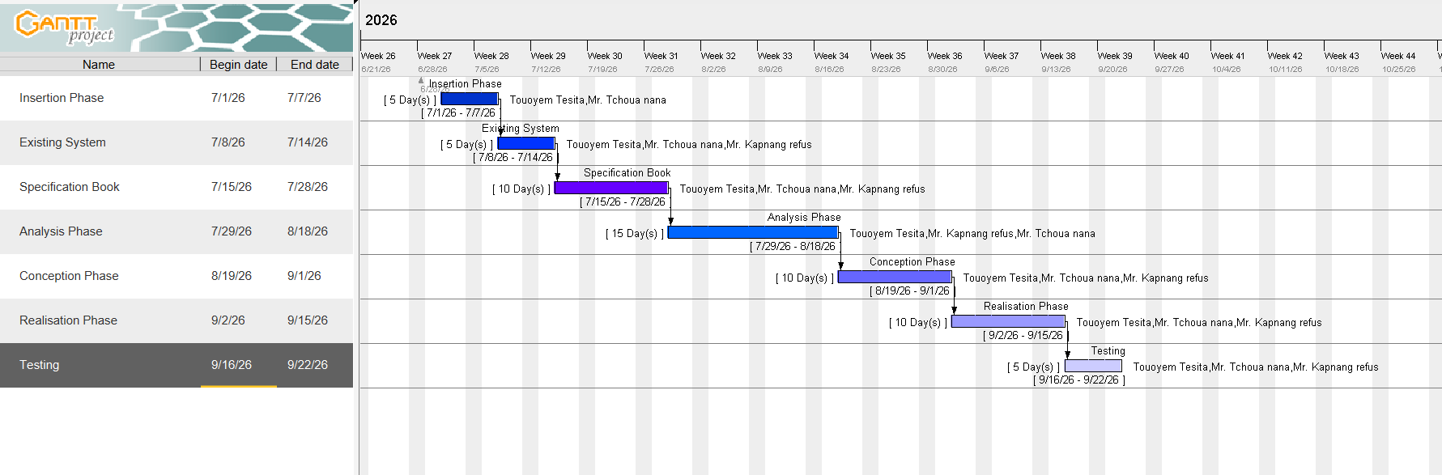
figure. Gantt chart 1

PROJECT CONSTRAINTS

To put in place this application, we must respect three main constraints which includes:
- Budget Constraint: the fixed budget for the realization of this project must be strictly respected.
- The Dateline Constraint: the realization of this system must respect the dateline attributed to it and should be completed in a duration of two months (2) including respecting the fixed objectives of the project.

- Quality Constraint: after fixing the budget and a dateline, we must produce a flexible, standalone and reusable application

DELIVERABLES

- In this section. We will present the different elements that will be delivered at the end of this project. They include:
- A CD-ROM containing the web application;

- The installation guide and user manual of the application;

- Presentation of the application;

CONCLUSION
To conclude the specification book has permitted us to present the general and specific objectives of the project, the project constraints, the functional and nonfunctional need of the project, lay out the different resources of the project and finally the project planning. The end of this document will now enable us easily dive into drafting the analysis document which will bring out the technical aspects of the project as a whole.

CHAPTER III: ANALYSIS PHASE

A. Methodology
Analysis is the fundamental step in the conception of a software. It is the basis for the realization of every information system. An information system is an organization of resources (human, software, and hardware), data, and feedback mechanisms aimed at attaining a specific objective.
Several methods and languages have been put in place to facilitate the analysis and conception of information systems, principally UML and MERISE.
MERISE (Méthode d'Étude et de Réalisation Informatique pour les Systèmes d'Entreprise) is a method of analysis, conception, and realization of information systems, mostly used in French-speaking companies or enterprises. It is based on the separation of data and processing, using several conceptual and physical models. Its principal objective is to conceive an information system. Merise proposes to consider the real system from two points of view:
- The Static View (data);
- The Dynamic View (treatments/processes).
It is a systematic and conceptual method of analysis.
UML (Unified Modeling Language) is a modeling language that provides a standardized, visualized view of an information system. It uses diagrams to represent each aspect of a system in an object-oriented way. UML proposes an approach different from MERISE, in that its readability and reusability make it an ideal choice for programmers.
UML is currently at its 2.5 version and presents a number of advantages, which include:
- It is a formal and standardized language.
- It provides visual representation of the structure and behavior of the system, which helps to communicate and understand the design of the system.
- It is flexible and customizable to suit different domains and technologies.
- It is readable and reusable, i.e., you can easily see the relationships and interactions between classes and objects in UML.
- We can present the UML hierarchy as follows:
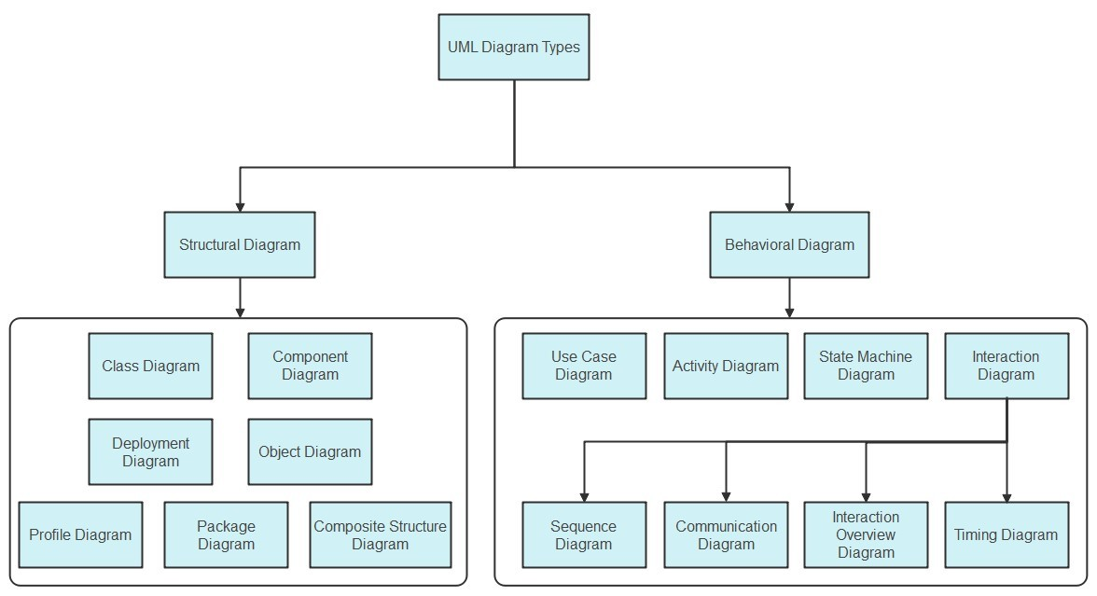
Figure12UML HEIRACHY

COMPARATIVE STUDY BETWEEN UML AND MERISE
Figure13comparative study between uml and merise
MERISE | UML
Méthode d’Etude et de Realization Informatique pour les Systèmes d’Entreprise | Unified Modeling Language
Merise is a method of analysis | UML is modeling language
Merise is a systematic method of analysis and design for information systems i.e. it uses a system approach | UML is however not a method but rather an object-oriented language, uses the 2TUP approach to model a system
It is based on procedural approach | Based on object approach
Merise proposes to consider the real system from two points of view:  - The Static view(data)  - The Dynamic view(treatments)  Which means in Merise we have a separate study of data and treatments | UML offers a different approach from that of MERISE in that it combines data and process

PRESENTATION OF THE 2-TUP METHOD
2-TUP(Two Track Unified Process) is Y in shape is a unified process which has as objectives to bring a solution to constraints of fuctional changes imposed on information system .It proposes a development cycle which seperetes the functional aspects from the technical aspects 2-TUP therefore distinguishes two main branches.
(The functional and technical branch) which their different results are being merged to realize our system.
Any unified process UP (Unifies Process) process meets the following characteristics: It is iterative and incremental. Some of the advantages of the 2TUP method includes:
- It allows flexibility in the analysis of a project

- It is easy to design and understand

- It allows to have a preliminary view

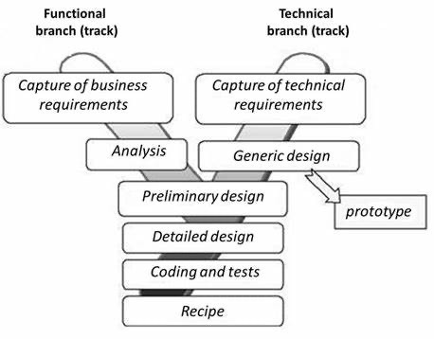

REALIZ
Figure 142-TUP

This process is articulated with these essential phases:
- The Functional Branch: this branch captures business needs, resulting in a model focused on the end-user’s requirements.
- The Technical Branch: this branch proposes a generic design from the technical needs, identifies the materials, tools and technologies to be used.
- The Implementation: The implementation phase consists of bringing the two branches together, providing the application design and finally the delivery of a solution adapted to the needs.
- Functional Branch (left branch)

- Capture of Business Needs: this part minimizes the risk of producing an inadequate system with the needs of users and also verifies it consistency.
- Analysis: this is the study of the specifications to find out what the system will be made of in terms of the business rules. We have the following diagrams: Use Case, Activity Diagram, State Machine Diagram, Communication diagram
- Technical Branch

- Capture of Technical Needs: this stage consists of the identification of tool, materials and technologies to use in developing the system. This technical architecture will be presented in this stage.
- Generic Designs: the technical architecture will be presented in this stage. We have the following diagram: mockUp7 Design.
- Implementation Branch (middle branch):

Preliminary Branch: this is the stage where the analysis model is integrated into the technical architecture. The goal here is to know what

- technical component will be used depending on the features of the analysis. We have the following diagrams: interaction overview,
- Component, Deployment, package diagram and Composite Diagram.
- Detailed Design: this is the detailed design of each feature of the system. We have the following diagrams: class, object, sequence and timing Diagrams.
- Coding and Testing: This is the programming phase of the designed features alongside testing of the coded features.
- Recipe (Result): this is the validation phase of the functions of the system developed.

A. CHARACTERISTICS OF 2TUP

The two-track unified process was built to be used with the Unified Modelling Language and has the following characteristics:
- It is user oriented: 2TUP is built from user’s expectation

- It is component oriented: it offers flexibility to the model by supporting the re-use of components.
- It is an iterative process: processes are being done in iterations and each iteration shows a precise level of abstraction.
- It is an incremental process: allowing a better functional and technical risk management and thus constituting the deadlines and the cost control.
- JUSTIFICATION ON THE CHOICE OF THE ANALYSIS

Our choice was based on the modelling language UML associated to it a method of analysis 2TUP due to certain criterion which are as follows:

- UML is based on object-oriented approach;

- UML associate’s data and treats them;

- It is a modelling language which focus mainly on users’ needs and expectations;

- 2TUP is a process built from object-oriented approach and is built from UML;
- 2TUP facilitates the modelling of complex systems which can further be readjusted.

MODELING

  - USE CASE DIAGRAM
The use case diagram simply shows the functionalities of the system, their interdependency and how they can be linked with actors of the system. It also clearly defines the boundaries of the system.
- Formalism:
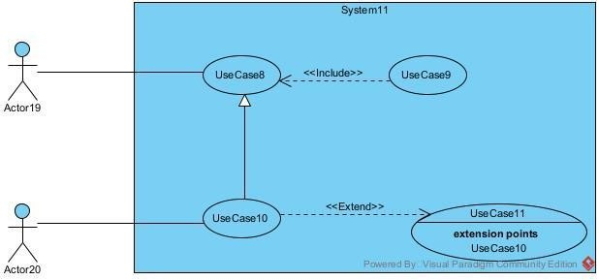

Figure 15USECASE formalism

- Components of a Use Case Diagram
Figure16components of the use case diagram
Actor | Represents the entity who directly interacts with the system. The actor is who performs the different task or actions of the system. | 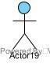
Use Case | it represents a functionality of the system. It is an action that can be performed by an actor | 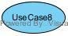
Generalization | It shows that a use case is a kind of another. This relationship permit the decomposition of a complex use case to simpler ones. | 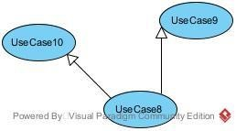
Inheritance | this is the only possible relationship that can exist between actors whereby an actor can inherit from another | 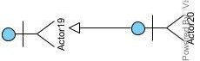
Inclusion | It is denotes that an included action must be performed before another action can be done. | 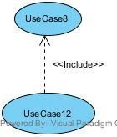

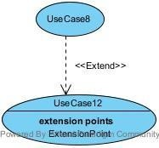
It denotes that an action may be performed while another action is going on e.g. a use case B extends A implies B is an optional part of A.
Extension
iv) Graphical representation of use cases (General use case)
Figure 17graphical representation of the usecase diagram

MANAGE USER SPECIFIC USECASE(ADMIN)
Figure 18manage user specific usecase

MANAGE ACCOUNT SPECIFIC USECASE(PASSENGER)
Figure 19manage account specific usecase(passenger)

TEXTUAL DESCRIPTION OF SOME USE CASES
Every use case is associated to a series of actions representing a given function. A use case is then an abstraction of a chain of executions. Implies an instance of a use case is known as a ‘’scenario” which is a series of steps undertaken to execute a specific use case.
The Textual description is a simple text that describes how a use case can be performed in a more precise and understandable way following a chronological order. We will present in the following lines the textual description of some use cases.
- Use Case<Authentication>>
Table 1textual description of some usecase
Use Case « Authentication »

Actor | passenger, driver, admins
Objective | Be able to connect to the platform and  perform task
Precondition | The actor must enter the url
Trigger | 1) User clicks on Authentication button.
Nominal scenario | - System displays login form.  - User fill and submit form.  - Verifies form conformity  - Send query to verify email  - Send password to very if password match  - system render users’ page.
Alternative Scenario (invalid credentials) | - From step (3) above if form not correct system display error message  - From step (4) if email not found system display error message  - From step (6) if password not matched  system display error message
Exception Scenario | 11) From step (4) above if there is inter connection problem  system display error message
Post-condition(s) | user landing page is displayed
Table 2generate time table textual description
Use Case « create user »
Actor | Admin
Objective | Be able to create a user
Precondition | The actor must authenticate
Trigger | 1) User clicks on create user button.
Nominal scenario | - System displays create form.  - User fill and submit form.  - Verifies form conformity  - Send query to verify if course exist  - Send query to save course  - System displays success message.
Alternative Scenario (invalid credentials) | - From step (3) above if form not correct system display error message  - From step (4) if course found system  display error message
Exception Scenario | - From step (4) above if there is inter connection problem  system display error message  - From step (5) above if there is inter connection problem  system display error message
Post-condition(s) | Course is created

2.2 COMMUNICATION DIAGRAM
- Definition
The communication diagram is used to model the specific interaction between the participants of the system. It describes both the static and dynamic behavior of the system. It shows the chronological succession of the actions performed by an actor in order to realize an operation.
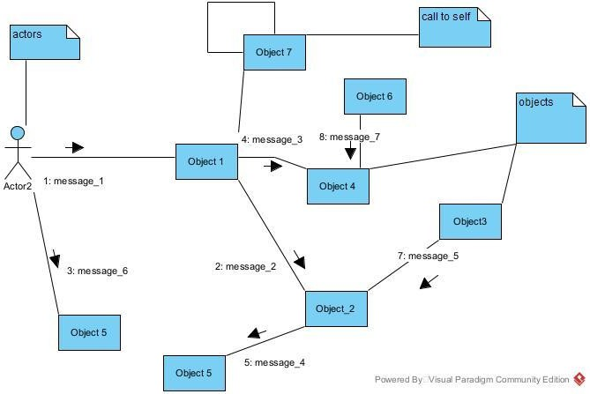
- Formalism

Table 3comunication diagram formalism

- Components of a Communication Diagram
Table 4component of the communication diagram
Element | Description and properties | Representation
Object | Represents a role or object instance that participated in t interaction model. | 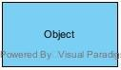

Call Message | A message that represents invocation of operation of t target o bject | 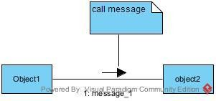
Actor | It models the type of r played by an entity that inter with the subject | 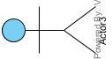
Generalization | Exist between two relation  classes where one is specialized form of the other | 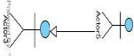
Anchor | A connector that connect t note shape for attaching additional description of the connected model element | 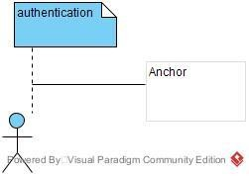

- Communication diagram for <<Authentication>>
Figure 20communication diagram of authentication

- Communication Diagram <<block user>>
Figure 21communication diagram block user

Communication Diagram <<delete contact >>
Figure 22communication diagram block user

2.3. SEQUENCE DIAGRAM

- Definition
A sequence diagram is a UML diagram that illustrates the sequence of messages between
objects in an interaction. It consists of a group of objects that are presented by lifelines and the messages that they exchange over time during the interaction. These interactions are arranged from top to bottom following their order of occurrence.
- Formalism
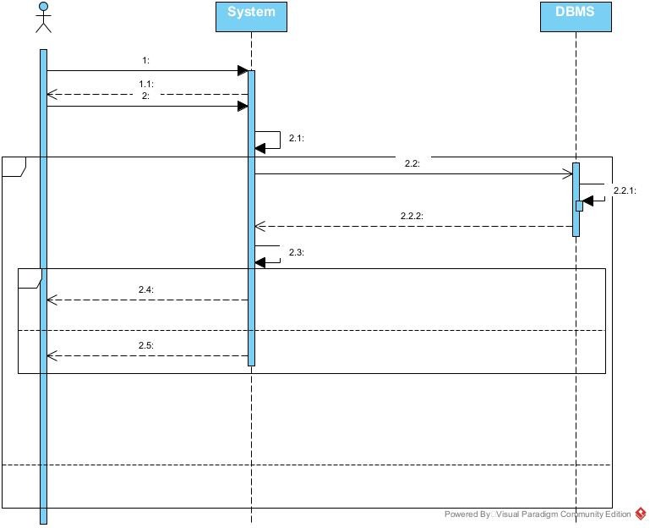
Figure 23sequence diagram formalisme

- Components of a Sequence Diagram
Table 5component of the sequence diagram
Element Description and main properties Representation
Lifeline | 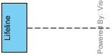  They represent rows or obj instances that participates in sequence being modeled.
Synchronous Message | A message that represented an invocation of an operation of the target lifeline | 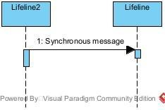
Self Message | Represents the execution operation call on the same objec | 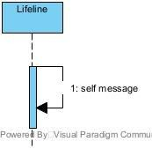
Destroy Message | It destroys a participant in the course of a process | 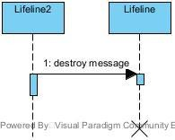

Sequence Diagram <<Authentication>>
Figure 24sequence authentication
- Sequence Diagram <<block user>>

Figure 25sequence block user
Sequence Diagram <<delete contact>>

Figure 26sequence delete contact

2.4 ACTIVITY DIAGRAM

- Definition
An activity diagram provides a view of the behaviour of a system by describing a sequence of actions in the process. The activity diagram makes it possible to emphasize the processing and to graphically formalize the sequence of actors carried out in a use case.
- Formalism
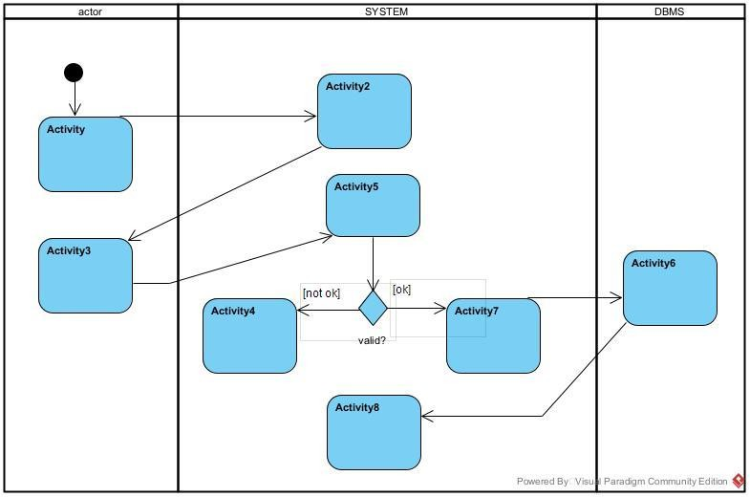

Table 6formalism of the activity diagram

- Components of an Activity Diagram
Table 7components of an activity diagram
k
Decision node | It is a decision node that ta token (condition) from one end and presents the different options or possibilities to crossple goings edges. It is generally represented by a diamond | 
Initial Node | It is a control node which flow starts when the activity is invoked
Final Node | A control node that stops all flow in an activity. It is represented circle with a filled circle inside
Control Flow | An edge that starts and activ node after the previous one is finishe | 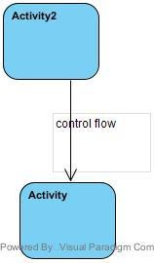
Action | Represents a single step in activity which cannot be further decomposed | 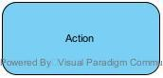

- Activity Diagram<< Authentication>
Figure 27activity diagram authentication
- Activity Diagram<< scan QR CODE>>
Figure 28activity diagram of scan QR code
Activity Diagram<<BLOCK USER >
Figure 29activity of block user

Activity Diagram<<DELETE CONTACT >
Figure 30activity diagram of delete contact

CONCLUSION
Having reached the end of our analysis, we were asked to illustrate the language and method used during this phase, present the different diagrams of the functional branch. we can then say that this analysis file has allowed us delimit the functional needs of the web application that will be designed and to have a detailed overview of the new system to be set up without notwithstanding we quickly dive into the conception phase

CHAPTER IV : CONCEPTION PHASE

INTRODUCTICON
I :CLASS DIAGRAM
II :STATE MACHINE DIAGRAM
II :PACKAGE DIAGRAM
CONCLUSION

INTRODUCTION
The realization of an analysis file is very important for the advancement of the application; it guarantees the reliability of maintenance and use of a software. That said, after analysing our system, we will move on to the design of our future system. To do this we will follow the steps of the technical branch of the 2TUP process, making the diagrams associated with these steps namely the class diagram and the state machine diagram.

A. CAPTURE OF TECHNICAL NEEDS

PHYSICAL ARCHITECTURE
The design of the database heavily relies on its underlying architecture. In this project, we utilized an n-tier architecture, a software design pattern that partitions the entire system into multiple, related but separate layers or tiers. This separation allows for greater flexibility, scalability, and maintainability, as each tier can be independently modified, altered, changed, or replaced without affecting the entire system.
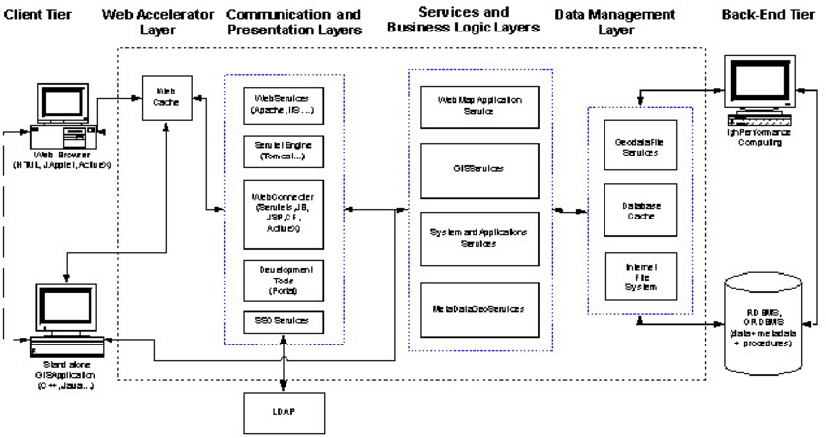
Source: https://www.mindphp.com/images
Figure 31system physical architecture

LOGICAL ARCHITECTURE
The application logic of our system is based on MVC design pattern which is a very practical way to organize the different classes in an application development project facilitating error detection, collaboration, and code reusability.
MVC (Model View Controller) design pattern is an architecture and a design method that organizes the human-machine interface (HMI), a view (user Interface) and a controller (Control Logic, event management, synchronization), each having a specific role in the interface.
This design pattern allows you to organize your code well, its goal is to separate you code into three main parts and in separate files namely: Model, View, Controller
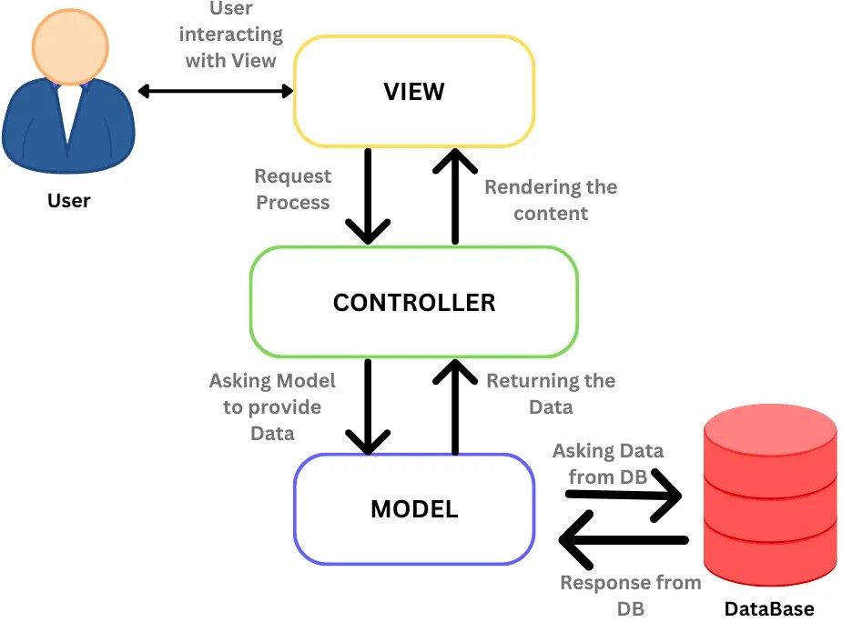

Figure 32MVC illustration

Source: https://www.mindphp.com/images/knowledge/IOT/ASP.NET-MVC.JPG

I. CLASS DIAGRAM
    - Definition
The class diagram expresses the static structure of the system in terms of classes and the relationships between those classes. The interest of the class diagram is to model the entities of the information system. The class diagram is used to represent all the finalized information that is managed by the domain. This information is being structured, that is, it has been grouped into classes.
ii. Formalism
The diagram highlights possible relationships between these classes. A class is a set of elements of the same nature that can be uniquely identified. This diagram has several concepts: class, attribute, identifier, method, access modifier. (Public (+), protected (#), private (-), package (), derivative (/)), relationships and crossplicities. The table below shows the different components of a class.
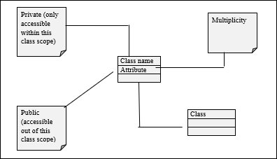
Figure 33class diagram formalism

Components of a Class Diagram
Table 8component of class diagram
Element Description and main features Representation
Class | Represents an entity within a system. It is an abstract representation or description of a set of objects in the application  domain | 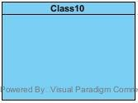
Generalization | 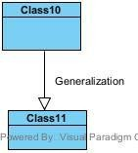  Exist between two related classes where one is a specialized form of the other.
N-ary relation | 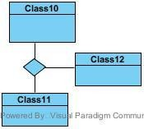  It is a type of relationship used to model several classes
Composite Association | It is a type of association t represents a part-wh relationship in which one elem dies too when the other dies. It represented by a black diamond | 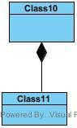
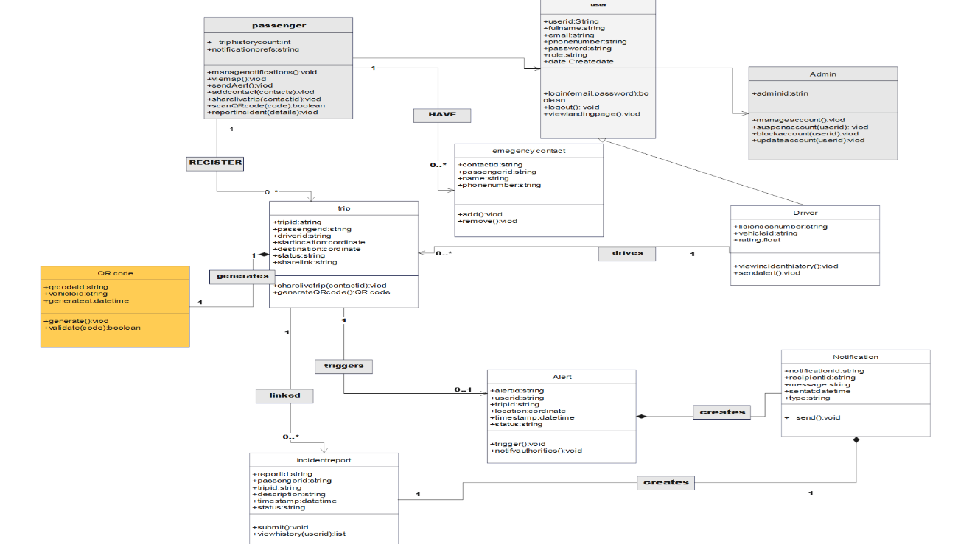
Graphical Representation of System Class Diagram

Table 9graphical representation of the class diagram

II. STATE MACHINE DIAGRAM
- Definition
State diagrams are used to document the various modes (states) that a class can take, and the events that cause a state transition. Their role is to present the treatments (operations) that will manage the field studied. They define the sequence of class states, also known as the state chart diagram, which models the dynamic flow of control from the state of a particular object within a system.
- Formalism

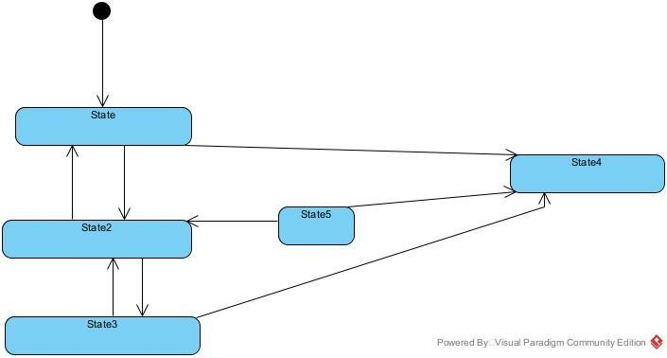
Figure 34state machine formalism

iii.Component of a state machine diagram
Table 10component of the state machine diagram
Element Description and features Representation
Initial State |   It represents the final or beginning of state and it is represented by a block filled circle
Final State |   It represents the final state or end of a system. It is represented by a filled circle within another circle
Transition | 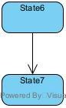  it is a change of control from one state to another due to the occurrence of some events. It is represented by an arrow labelled with the event that causes it’s change of state.
State Box | 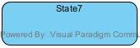  It depicts the condition or circumstances of particular object of a class at a specific point of time.

State Machine <<create account>>
Figure 35 create account

III. PACKAGE DIAGRAM
- Definition
They are structural diagrams used to show the organization and arrangement of various model elements in the form of a package. A package diagram is group of related UML elements such as diagrams, documents, classes, or even other packages. Package diagrams are commonly used to provide a visual organization of the architectural layout within any UML classifier such as software systems.
- Formalism

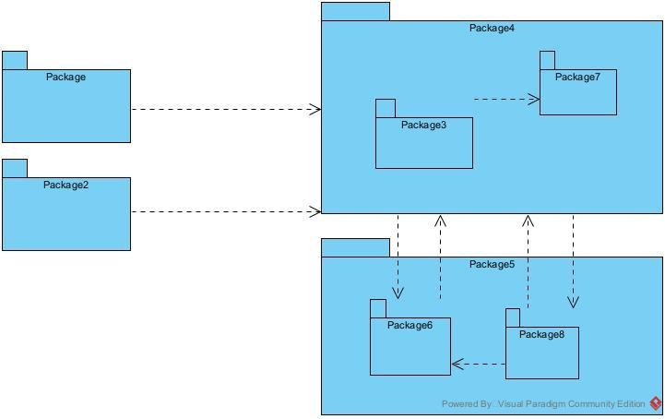
Figure 36pachege diagram formlism

- Component of package diagram
Table 11component of the package diagram
Element Description and main features Representation
Package | 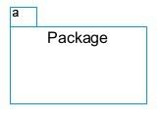  It is namespace used to group together logically related elements within a system. Each element contains within the package should be a packageable  element and have a unique name
Package import | A relationship Indicate that, functionality has been imported  from one package to another.  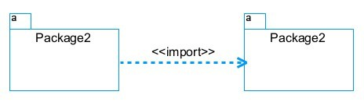
Package access | 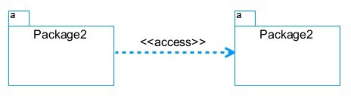  A relationship Indicates that one package requires assistance from the function of another package.
Package merge | 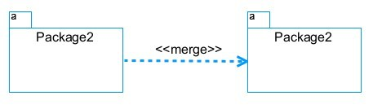  It is a relationship which shows that, the functionality of two packages are combines to a single function.

System package diagram

Figure 37pachage diagram

CONCLUSION
The conception phase allowed us to bring out the data necessary for the creation of our database and the implementation of our application. The different elements modeled in this part allowed us to have a global view of the different modules of our application; therefore, the next step of our project will be the drafting of the realization file taking into account the different elements modelled above.

CHAPTER VI: REALIZATION PHASE
Preamble

The realization document consists in the implementation of the project in a programming language according to the specifications defined in the previous file. It contains component and deployment diagrams; the testing and development phases. At the end of this part, programming documentation will be produced explaining the architecture of the database and the architecture of our code.
INTRODUCTION
- PRELIMINARY CONCEPTION

  - DEPLOYEMENT DIAGRAM
  - COMPONENT DIAGRAM
- TECHNOLOGICAL CHOICES
1.MATERIAL CHOICES
2.SOFTWARE CHOICES
3.TECHNOLOGICAL CHOICES

INTRODUCTION
Design and modelling are important links in the development process of an application because they make it possible to define and specify the different elements constituting the application or system studied. Realization is the culmination of the work carried out upstream because it makes it possible to physically create the various objects that were designed, and to bring the computer system to life. Throughout this phase, we will present the software, physical and hardware architecture of our system, through diagrams such as the component diagram, deployment diagram, physical model and code architecture.

DEPLOYMENT DIAGRAM

i. Definition
The deployment diagram models the hardware components used to implement a system and the association between those components. Deployment diagrams can be implemented as early as the design phase to document the physical architecture of the system. As elements used in deployment diagrams we can have, components, as in component diagrams, and nodes, which represent the physical processing resources of the system, and their associations.

ii.) Formalisme

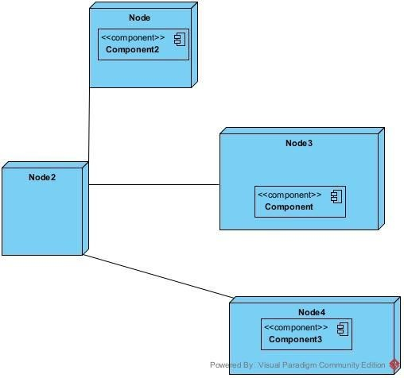

Figure 38component of the deployment diagram formalism

Components of a Deployment Diagram
Table 12component of the deployment diagram

Description and main
Element Representation features
Component | 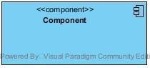  A component represents a software entity of the system
Node | 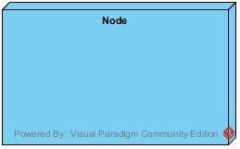  A node represents a set of hardware elements of the system. This entity or node is represented by a three  dimensional cube
Interface | 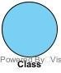  Represents a declaration of a set of coherent public features and obligations
Dependency (manifestation deployment) | 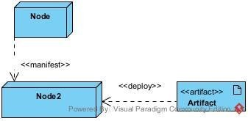  A relationship between two model elements where changes in one of them will similarly affect the other

iv. Deployment diagram

Figure 39deployment diagram

COMPONENT DIAGRAM
- Definition
The component diagram is a UML diagram that provides a graphical representation of dependencies and generalizations between software components, including source code components, binary code components, and executable components.
- Formalism

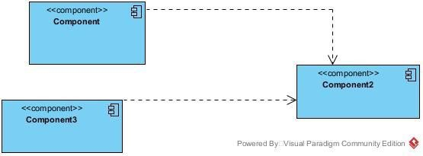

Figure 40components diagram formalism

Components of a Component Diagram
Table 13component of the component diagram
features | Description and m |  | Element Representation
Component | Represents t modular part of system t encapsulates its content. other words it is  parts that of a syst or application. |  | 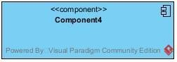
Interface | Represents declaration of a  set of coherent pub  features  and obligations |  | 
Part | Specifies a disti interaction  point between that  classifier elem and its environment |  | 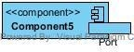
Usage |  | 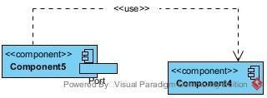  A relationship in which one element requires another element for it’s full  implementation operation

- Component Diagram

Figure 41component diagram

TECHNICAL CHOICES
A. Materials used for the development
i. Hardware Material
Table 14hardware material use for the developmentt

Material |  |  | Quantity Function | Image
Dell LATITUDE E7540 |  |  |   1 The computer was used for the programming of the micro controller, the analysis, research, the design of the system architecture. This was the main component in  this project.
HP computer |  |  | 1 The computer was used for the development of the mobile application    and web application
iPhone max | 11 | pro | 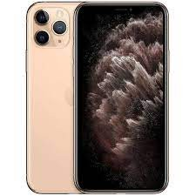  1 Testing the mobile app functionalities and debugging.
V

Software | Role | Reason for use Image
OS WINDOWS 10 | The operating system required to run the software is the one on which we have worked. |   Windows 10 has a user-friendly interface that is familiar to many users, making it easy to navigate  and use.
Visual Paradigm | The software engineering workshop used for solution modelling. We utilized this tool for modelling the various diagrams of  our system |   . Supports multiple modelling languages and methodologies, making it suitable for various project requirements and enabling teams to adapt to different  development processes.
Visual | Visual Studio Code is a lightweight, open-source code editor developed by Microsoft, supporting multiple programming languages. Using for writing of application  code. |   . Combines tools for version control, debugging, and terminal access in one interface, improving efficiency and reducing the need for multiple applications.
studio code
Github | It is a website and cloud service that helps developers store and manage their code. |   Git allows developers to track changes, revert to previous versions, and maintain a history of  modifications, ensuring that

 | no work is lost and enabling easy recovery.
 | A popular open-source
 | framework for building
 | natively compiled, cross- |  |  | Promotes the creation of
Flutter Framework | platform applications. Provides a widget-based  approach for efficient |  |  | reusable components,  which enhances code maintainability and allows
 | rendering | and | state | for easier updates |   and
 | management |  |  | testing.
Node.js | Node.js is an open-source and cross-platform JavaScript runtime environment. It is a popular tool for almost any kind of  project! |  |  |   It is used to build our backend, helping us to have a dynamic web application
MySQL | MySQL is a popular open-source relational database management system |  |  | It is used to store manage our data |   and
MS Excel | MS Excel is a powerful spreadsheet application used for data organization, analysis, and visualization. Using  to create charts after the |  |  |   Provides a variety of charting and graphing options, helping users to present data in a visually appealing and easily  understandable format

 |  | collection of data from the survey.
 | MS Word | MS Word is a widely used word processing application that allows users to create, edit, and format text documents. Using in application  report creation. | Offers extensive options for formatting text, images, and layouts, enabling the creation of professional quality documents. | 
 | MS Power Point | MS PowerPoint is a presentation software that allows users to create dynamic slideshows comprising text, images, videos, and animations. Able us to create slideshows presentations for  application. | Its intuitive interface and templates make it easy for users to create professional presentations quickly, regardless of their technical skill level | 
 | Chrome | Google Chrome is a fast, secure, and user-friendly web browser developed by Google. Used to test our application UI | Chrome is optimized for fast page loading and efficient resource management, providing a smooth browsing  experience. | 
 | GanttProject | GanttProject is a free, open-source project management tool that | Allows users to assign tasks, set deadlines, and manage resources | 

CONCLUSION
In our realization phase, we set as objective to plane the different aspect of our system by showing how it will be structure and deployed within existing technical architectures. We began by taking into account the technical constraints for our system, after which we proceeded to identify the components of our system, how they are grouped together and how they should be deployed on appropriate deployment targets. We finished this phase by looking at interactions between the various aspects and actors of our system. The next phase of our report is the realization phase where we will look at aspects concerning the implementation of our system

CHAPTER VII: FUNCTIONALITY TESTING
Preamble

This phase aims at testing the software or application to verify if the system is working as expected. It involves testing individual functionalities and capabilities of the software to ensure that they work correctly and meets the specified needs.

Content :
INTRODUCTION
- APPLICATION MODULES
- UNIT TESTING CONCLUSION

INTRODUCTION
It is a systematic process that involves evaluating the functionality of a software application or system in different phases or stages of its development lifecycle. This testing approach ensures that each phase of the software development process is thoroughly tested for its intended functionalities and overall performance. Its main goal is to identify and rectify any defects, and bugs during the process

\

APPLICTION FUNCTIONALITIES

Authentication
Authentication is a fundamental functionality of the system that verifies the identity of users (passenger, driver, Admin). It ensures that only authorized individuals or entities can gain access to protected information or perform specific operations, such as sharing live trip locations, sending emergency alerts, reporting incidents, or managing accounts.
Given the security-critical nature of the Smart Urban Taxi Security and Incident Detection System, authentication also plays a role in verifying the identity of drivers and taxis (through the QR code scanning mechanism) before a passenger boards, ensuring that both the digital account and the physical taxi/driver pairing can be trusted.

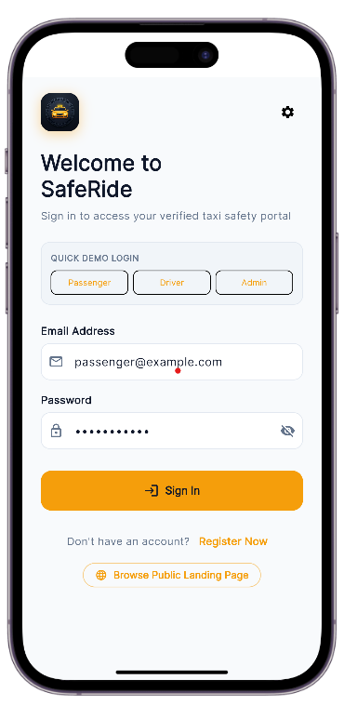
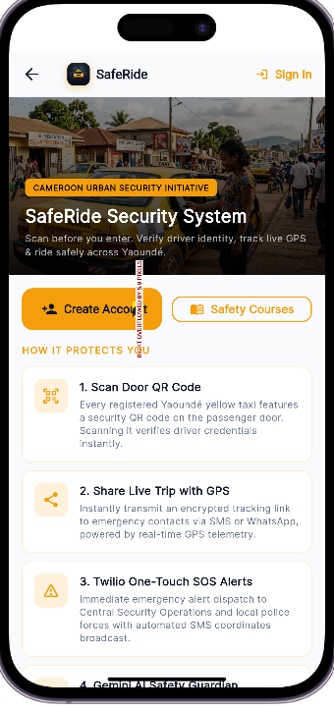

VERIFIED TAXI TRACKING IN RIDE HAILING
The screen below shows the a home dashboard with live trip tracking a “scan taxi QR before entering”safety feautures ,a passenger academy learning module ,and a list of nearby verified taxis with driver vehicle details and ratings
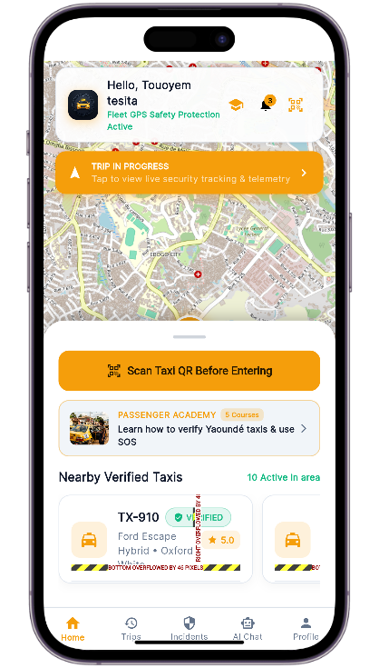

TRIP HISTORY AND REPORT INCIDENTS
Image 1 – Trip History & Safety Audits: Shows a log of past and current taxi trips, listing trip status (Requested/Completed), pickup/drop-off locations, passenger name, timestamp, and fare — letting users review and audit their ride history for safety and billing purposes.
Image 2 – Report Security Incident: A form for passengers to report safety issues (e.g., driver harassment/threats) by selecting an incident category, adding a title and detailed description, and auto-capturing GPS location — with reports routed directly to Transit Police and the Taxi Security Board for review.
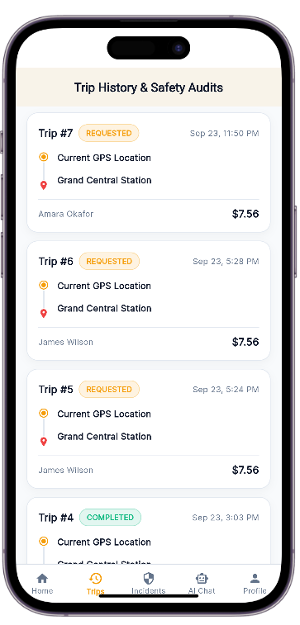
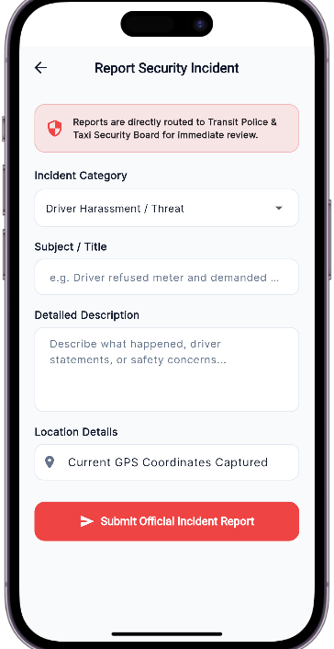

AI-Powered Safety Assistance & Emergency Contact Alerts
Image 1 – Gemini Safety AI: An in-app 24/7 AI chat assistant that analyzes conversations in real time to detect hazards, offering quick-tap help options like taxi QR verification, feeling unsafe, night safety tips, and how the SOS alert works.
Image 2 – Emergency Trusted Contacts: A screen where users add trusted contacts (with phone numbers and relationship) who automatically receive the user's live GPS location whenever they trigger SOS or start a taxi ride.
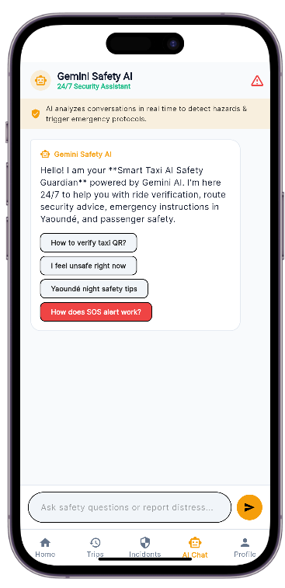
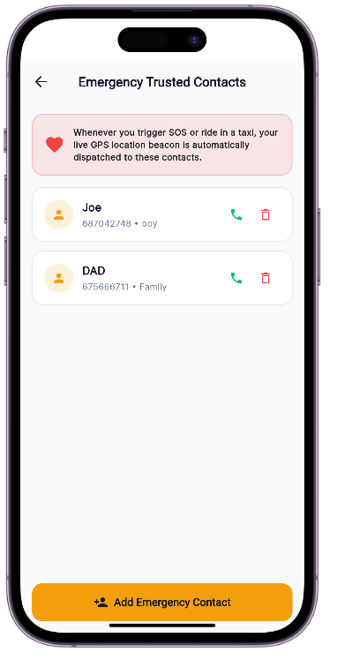

: User Profile Management & Taxi Verification via QR Scanning
Image 1 – Security & Profile: Displays the user's verified passenger profile (name, email, ID verification badge) along with account settings such as managing trusted emergency contacts, toggling dark theme mode, viewing backend API configuration, and signing out.
Image 2 – Scan Taxi Security QR: A camera scanner screen for verifying a taxi's legitimacy by scanning the official QR code (located on the passenger door or dash), which confirms licensing and links live GPS safety tracking — warning users never to board an unverified taxi.
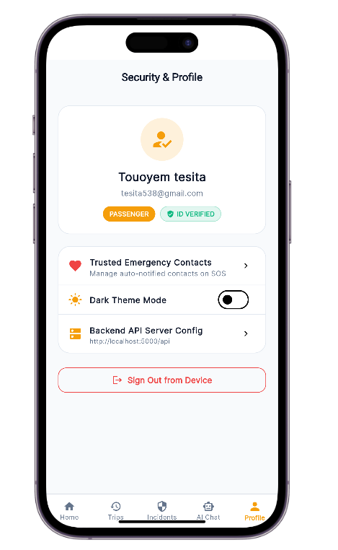” 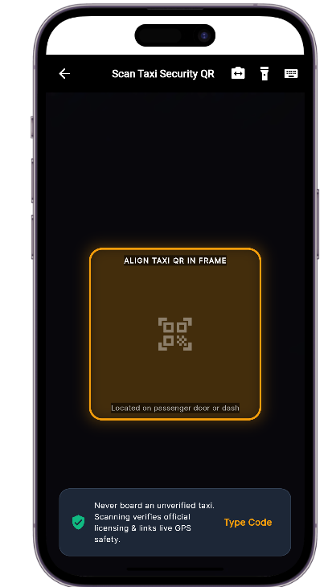

II. UNIT TESTING
Unit testing refers to testing a function individually, to ensure that it is working properly. Here are some unit test of our solution:
TEST 1=REGISTER
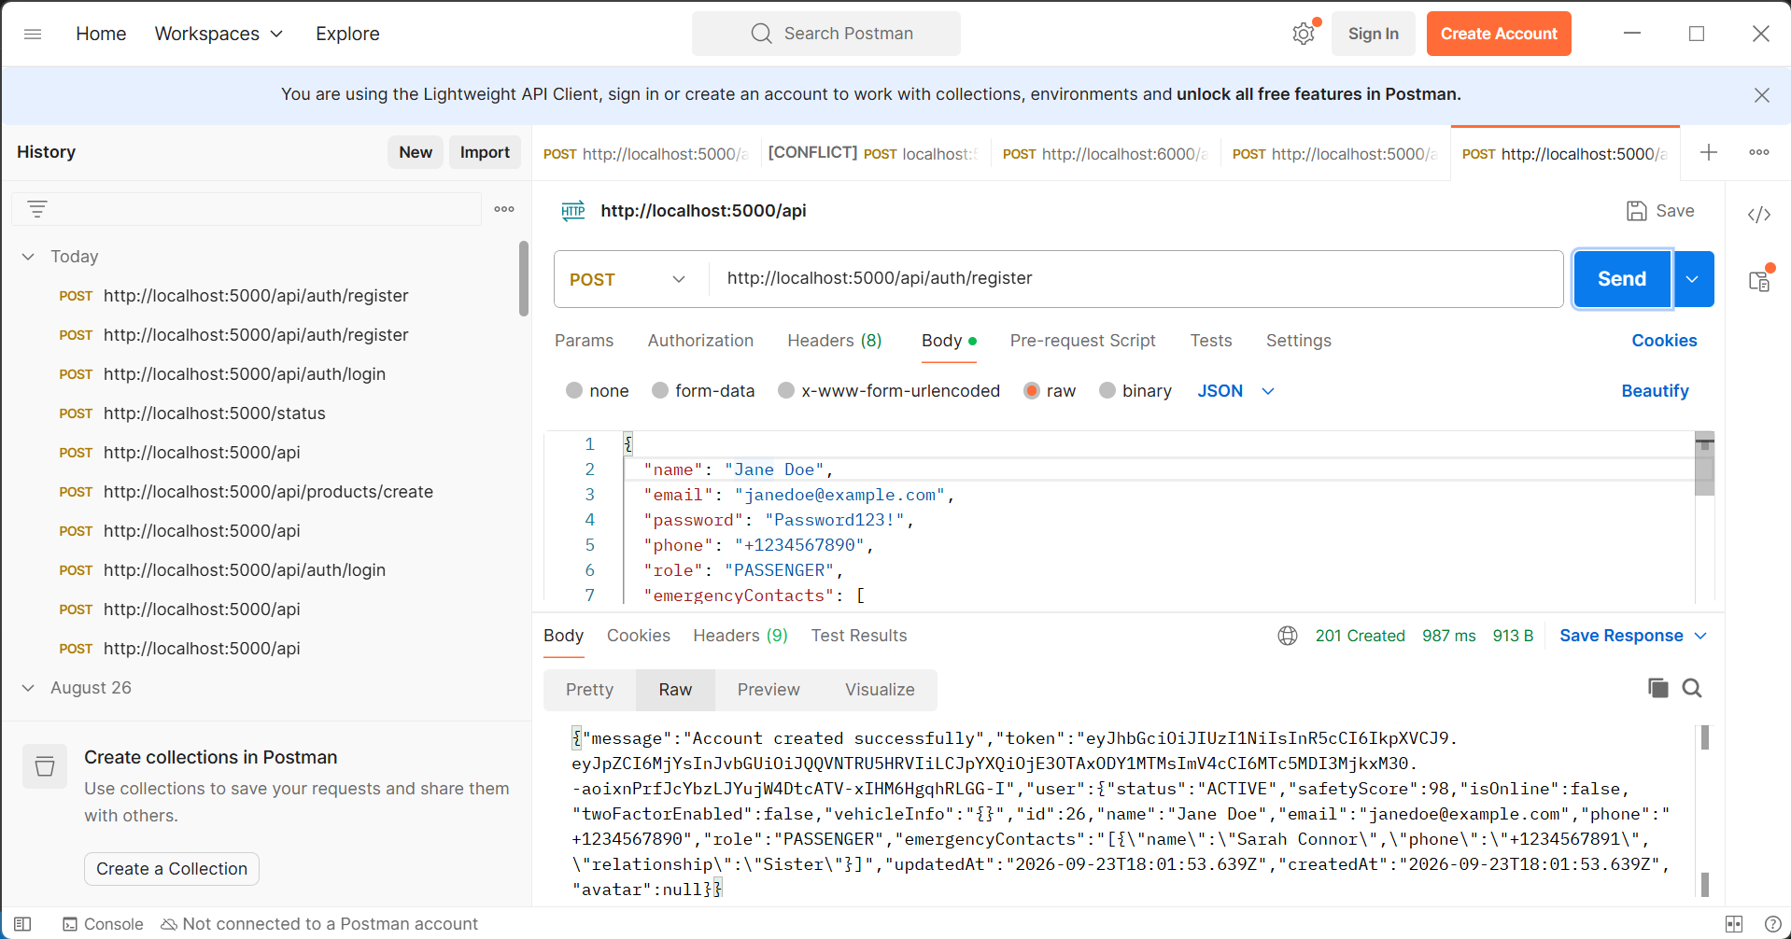

TEST 2=LOGIN
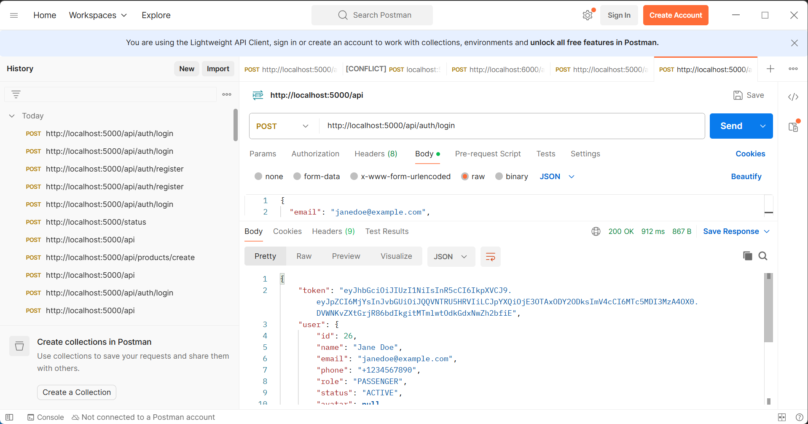

CONCLUSION
Testing is an integral part of the software development life cycle and is performed to verify the correctness, reliability, and robustness of the implemented functionality. the functionality and testing phase are therefore a critical stage in software development where the implemented features are validated, and any issues are identified and resolved.

CHAPTER VII: INSTALLATION GUIDE AND USER GUIDE
Preamble

A user guide explains how to use a software application in a language that a non-
technical person can understand. Thus, it enables the user to easily use the application to familiarize with the software and discover all the its functionalities.

INTRODUCTION
- DESCRIPTION OF THE APPLICATION
- INSTALATION GUIDE
- USER GUIDE CONCLUSION

INTRODUCTION
The user manual is the document established after the realization of an application, software or platform. It informs on the question "how to use the software, the application or the platform that you have in front of you? ". It is therefore crucial for us to offer the various users of our platform a guide allowing them to easily perform various operations on our platform.

